Saxmundham Town Council
Resources 26th of April 2021

Item no: | 6
Report dated: | Thursday, 22 April 2021
To the: | Resources Committee
Meeting on: | 26 of April 2021
Subject: | Financial Regulations - Payments Approval Paper
Contact/author: | Roz Barnett – Town Clerk

- Summary.

Issue 1
In reviewing the end of year paperwork, the Clerk has found that between the records of payments approved and the actual payments made there are several discrepancies. This is because the list of payments for approval that are taken to the Resources Committee are a snapshot in time. There maybe direct debit payments or payments that are made at the end of the month that get omitted from the payment list which means that the Town Council are not being presented with the full information.

The payment list for approval is also being prepared outside of the Rialtas software system so there is also an issue of not looking at the actual data that is being inputted into the programme and this creates the opportunity for error.

Issue 2
For efficiency, within a larger council payment may need to be made throughout the month. The reasons why this is important are: -
- To prevent unnecessary delays into operations while waiting for Committee meetings.
- Some smaller suppliers require quick payment (Especially due to Covid-19).
- There is not a petty cash system so timely reimbursement is important.
- If the Council works with businesses and community organisations, to deliver events, payments will need to be made timely.

Custom and practice in Town Councils is that normally the clerk would make a payment without the payment being authorised by committee in these circumstances:
- There was money in the budget,
- It had been duly authorised at a committee or was within the delegated authorisation of expenditure.
- Payment was made in consultation with the relevant chairs and reported back to Council at the first possible opportunity.
- SALC has advised that the auditors would not normally pick up whether a payment has been authorised if the expenditure had been clearly authorised but making payments within the month is not allowed within the existing financial regulations and an amendment would be required.

Issue 3
Sometimes the Clerk is expecting an invoice that must be paid by a certain date but may not yet have received the invoice or the works completed. This is a particular issue at the end of the financial year. This means that some payment may be listed when the works have been completed but the invoice not yet received.

Issue 4
The current financial regulations state the clerk is required to seek 3 estimates for expenditure over £100.
h) When it is to enter into a contract of less than £25,000 in value for the supply of goods or materials or for the execution of works or specialist services other than such goods, materials, works or specialist services as are excepted as set out in paragraph (a) the Clerk or RFO shall obtain 3 quotations (priced descriptions of the proposed supply); where the value is below [£3,000] and above [£100] the Clerk or RFO shall strive to obtain 3 estimates. Otherwise, Regulation 10.3 above shall apply.

2.0 Options
The Clerk has discussed this issue with Local Clerks and looked at other financial regulations. Below are some of the amendments made by other councils.

Sudbury have made it payments over £500 requiring approval.
The RFO shall prepare a schedule of payments with the values over £500 requiring authorisation, forming part of the Agenda for the Meeting and present the schedule to the finance committee. The committee shall review the schedule for compliance and, having satisfied itself shall authorise payment by a resolution of the finance committee. The approved schedule shall be ruled off and initialled by the Chairman of the Meeting. A detailed list of all payments shall be disclosed within or as an attachment to the minutes of the meeting at which payment was authorised. Personal payments (including salaries, wages, expenses, and any payment made in relation to the termination of a contract of employment) may be summarised to remove public access to any personal information.
Thetford have gone for the ‘work in progress model’ stating that some payments have made and will ratified, and some payments are for approval.
The RFO shall prepare a schedule of all payments (including BACS, cheque payments, Direct Debits and Standing Orders) already made or to be made from the Council’s bank accounts. The payment schedule shall form part of the Agenda for the Finance Committee Meeting and the RFO shall present the payment schedule to the Finance Committee. The payment schedule will contain payments already made and which require ratification by the Finance Committee. The schedule will also contain payments that will still have to be made and these will need to be approved prospectively by the Finance Committee. The detailed list of all payments already made or still to be made shall be disclosed within or as an attachment to the minutes of the meeting at which payment was authorised. Personal payments (including salaries, wages, expenses and any payment made in relation to the termination of a contract of employment) may be summarised to remove public access to any personal information.
Stowmarket have gone for a ratification of payments made.
The RFO shall prepare and submit a schedule of payments to the Council for each month of the year and payments made shall be ratified by the Council. All invoices for payment shall be examined, verified and certified by a budget manager to confirm that the work, goods or services to which each invoice relates has been received, carried out, examined and represents expenditure previously approved by the Council.

Three estimates for expenditure over £100.
Larger councils have adopted a best value statement or a threshold over £2000. Medium Councils have adopted a threshold between £500 and £1000. Smaller Councillors have opted for a threshold between £100 and £500.

3.0 Recommendations.
Recommendation 1
That any reports to council Committee should be taken directly from the Rialtas System, to ensure councillors are looking at the actual data entered onto the system.

Recommendation 2
The RFO shall prepare and submit a complete schedule of actual payments and receipts to the Town Council for ratification each month.

Recommendation 3 - Amendment to the Financial Regulations - Payments

Remove
5.4. The RFO shall prepare a schedule of payments requiring authorisation, forming part of the Agenda for the Meeting and, together with the relevant invoices, present the schedule to Resources Committee. The Schedule shall indicate the items for which authority to spend was given by the Council or Committee, and those which are under the Clerk’s delegated authority.
5.5. The Committee shall review the schedule for compliance and, having satisfied itself shall authorise payment by a resolution. The approved schedule shall be signed and initialled by the Chairman of the Meeting. A detailed list of all payments shall be disclosed within, or as an attachment to, the minutes of the meeting at which payment was authorised. Personal payments (including salaries, wages, expenses and any payment made in relation to the termination of a contract of employment) may be summarised to remove public access to any personal information.
5.6. A schedule of payments requiring authorisation which cannot reasonably await the next Resources Committee meeting may be put to the full Council by the Clerk, following the same procedure as set out above.
5.7. The Clerk/ RFO shall have delegated authority to authorise the payment of items only in the following circumstances:
a) If a payment is necessary to avoid a charge to interest under the Late Payment of Commercial Debts (Interest) Act 1998, and the due date for payment is before the next scheduled Meeting of council, where the Clerk and RFO certify that there is no dispute or other reason to delay payment, provided that a list of such payments shall be submitted to the next appropriate meeting of the Resources Committee
b) An expenditure item authorised under 5.8 below (continuing contracts and obligations) provided that a list of such payments shall be submitted to the next appropriate meeting of the Resources Committee.
c) fund transfers within the council’s banking arrangements up to the sum of £10,000, provided that a list of such payments shall be submitted to the next appropriate meeting of the Resources Committee.

Replace with
The RFO shall prepare and submit a schedule of payments to the Council for each month of the year and payments made shall be ratified by the Council. All invoices for payment shall be examined, verified and certified by the Town Clerk to confirm that the work, goods or services to which each invoice relates has been received, carried out, examined and represents expenditure previously approved by the Council.

Recommendation 4 - Amendment to the Financial Regulations – Estimates

Current Wording
h) When it is to enter into a contract of less than £25,000 in value for the supply of goods or materials or for the execution of works or specialist services other than such goods, materials, works or specialist services as are excepted as set out in paragraph (a) the Clerk or RFO shall obtain 3 quotations (priced descriptions of the proposed supply); where the value is below [£3,000] and above [£100] the Clerk or RFO shall strive to obtain 3 estimates. Otherwise, Regulation 10.3 above shall apply,

Amend to
h) When it is to enter into a contract of less than £25,000 in value for the supply of goods or materials or for the execution of works or specialist services other than such goods, materials, works or specialist services as are excepted as set out in paragraph (a) the Clerk or RFO shall obtain 3 quotations (priced descriptions of the proposed supply); where the value is below [£3,000] and above [£1000] the Clerk or RFO shall strive to obtain 3 estimates. Otherwise, Regulation 10.3 above shall apply,

Recommendation 5 – Pre–approved/authorised payments.
To consider and approve pre-approved/authorisation payments for the financial year 2021-22

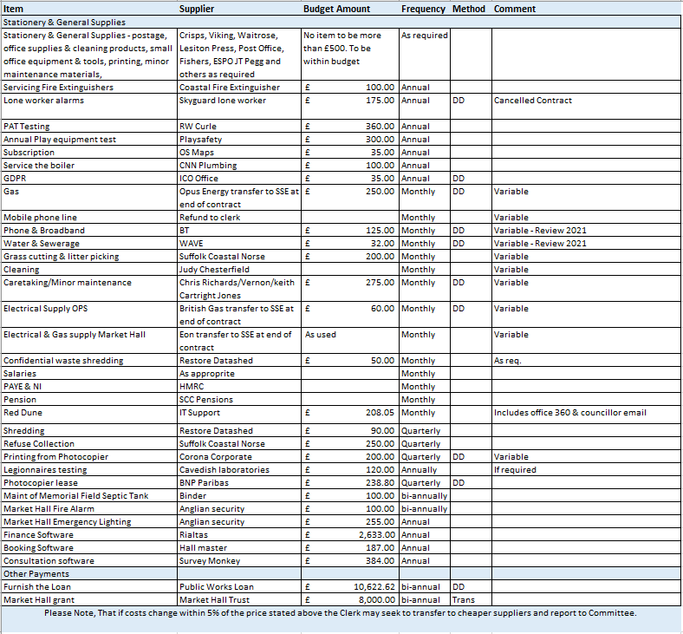

Item 7 VAT Underclaim
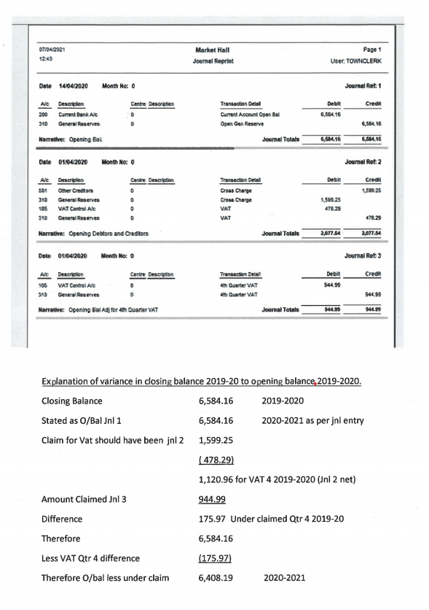

Item 7b  Subject: | No. | Risk identified | Potential impact  (H/M/L) | Level of risk  (H/M/L) | Management/Control of risk | Review/Assess/Revise
Business continuity | 1. | Council unable to continue business as a result of an unexpected or tragic event | H | L | All files and recent records are retained at the council’s office. There is a secure, cloud-based IT system for digital records. Paper documents, both current and archived, are filed in the Saxmundham Town House. | Review regular updating of user passwords.  Personnel files are stored in locked, metal filing cabinet.  All other paper-based documentation has been reviewed but historical documentation is yet to be logged and archived appropriately.  Assistant clerk and clerk share information about each other work.
Business  continuity | 2 | Town Clerk temporarily absent or otherwise unable to carry out duties. | H | M | In the event of the clerk being indisposed the assistant town clerk will provide clerical support. An operational plan is in place including temporary clerical support. | Ensure that both members of staff have reasonable day-to-day experience of all systems to ensure continuity.  Arrangements explored with SALC about cover for financial administration using Rialtas.  Council to revert to using cheques in an emergency.
Business continuity | 3. | Council records: Loss through damage, fire or theft | H | L | IT system files are backed-up using a cloud-based system. This occurs at file creation and updating. See Business Continuity 1. | Also refer to Business Continuity 1.  Provide an emergency contingency plan.
Business  continuity | 4 | Access to confidential information by non-authorised personnel. | M | L | Only the town clerk, the assistant town clerk and the IT administrator have access to the IT system. | Password updating procedure in place with our IT support.  Contact IT support if access is required.  See Financial Regulations.  Cabinets/Offices to be locked when Clerk/Assistant Clerk not present.
Business continuity | 5 | Meeting location adequacy: Health and Safety | H | L | Full Council meetings are normally held in the Market Hall. Committee meetings are normally held either in the Market Hall or Saxmundham Old Police Station. The clerk and assistant town clerk hold keys/access codes to both. The premises are considered satisfactory providing all statutory health and safety obligations are observed. | Statutory health and safety obligations for both the Market Hall and the old police station reviewed and will be continued Relevant documentation retained in STC Office.
Freedom of Information Act (FOA) | 1 | Policy Provision | M | L | The council has a model publication scheme for local Councils in place. The Town Clerk is aware that if a substantial request arrives it may necessitate additional hours of work. The council is able to request a fee if the work will take in excess of 15 hours to complete. The request can be resubmitted in sections to negate the payment of a fee. | Monitor any report and potential impacts made under the FOA.  Review files for any previous information requests.  On receipt of an FOI, the Chair and Vice-Chair should be informed and monitoring of compliance to time to respond should be monitored
Data Protection | 1. | Failure to comply with GDPR (General Data Protection Regulation) 2018 or later regulations | H | L | Follow good administrative practice for securing personal and GDPR related data | Members to receive a briefing on an annual basis.
Finance | 1. | Precept adequacy | H | L | Sound planning and budgeting process to support the annual precept requirement. The process should take account of each committees’ recommendations. The Resources Committee reviews the planned budget in October/November with recommendation/agreement by Full Council each January. | Minute to be made on budget, submission of precept request and receipt of precept payments.  Copy of the approved budget to be sent to all members.
Finance | 2. | Budgetary control | H | H | The RFO to regularly provide the council with regular updates regarding receipts and expenditure against each budget category. | Part of Financial Standing Orders Section 4. Budgetary Control and Authority to Spend. Financial Regulations reviewed 2020 and will be reviewed reported to Resource Committee & Council annually  Resources Committee to receive regular budget/forecast detailed update. Full council to receive regular updated summary budget sheet.
Finance | 3. | Insurance adequacy | M | H | Statutory requirement: Employers’ Liability, Public Liability, Fidelity Guarantee. Annual review completed. Part of annual audit. | Asset Register to be reviewed annually or updated more frequently as required.  Market Hall to have a separate asset list.  RFO to report to Council on general adequacy of insurance.
Finance | 4. | Banking: Adequacy of checking procedure | L | L | The council has agreed Financial Regulations which determine the procedure. Annual independent audit. | Review Financial Regulations annually and as required.  Online banking mandate to be reviewed by Full Council, when necessary.
Finance | 5. | Cash: Control to prevent loss through theft | H | L | Regular reconciliation of bank statements prepared by RFO. Checked and signed by designated Councillor. Two authorised signatures required for cheques.  Annual internal and external audits completed.  For internet banking payments will be initiated by the clerk and approved by an authorised signature. | Part of Financial Standing Orders. Review as required.  Review procedure for on-line banking and on-line payment authorisation. On-line banking mandate to be reviewed and agreed by Council
Finance | 6. | Approval of expenditure: authorisation levels | H | L | Any financial decision must be resolved and clearly recorded prior to any commitment. This usually takes place at Committee meetings.  All income and expenditure must be detailed in the monthly financial reports presented to the Resources Committee and Full Council. | Financial Regulations reviewed and specific limits specified.  Order sheet which contains authorisation notes and minute numbers to be completed by Clerk and Assistant Clerk.
Finance | 7. | Fraud | H | L | Internal procedures are observed. Fidelity Guarantee insurance must be in place. | Monitor adherence to Financial Regulations.  Annual check of fidelity insurance.
Finance | 8. | VAT & other Taxes | H | L | The council has Financial Regulations which define the requirements for VAT recovery which is completed on a quarterly basis.  PAYE tax & NI paid as defined by HMRC regulations. | Council to review the VAT in relation to the Market Hall.
Land and Property |  | Don’t have key documents of ownership and possession. | L | L | Clerk to review all documents and seeing information from Land registry where there are gaps | Council to consider whether to pursue registering any unregistered property/land
Land and Property |  | Licences and Leases ha | L | L | Clerk to review all documents and seeing information from Land registry where there are gaps | Council to consider whether to pursue registering any unregistered property/land
Liability | 1. | Damage to building assets, street furniture, IT equipment, play equipment and other equipment | M | L | An Asset Register is maintained, and insurance is held at the appropriate level for all items. Regular checks are made on all equipment by the appropriate service providers and members of the council. | A central log should be maintained for any items of equipment or documentation which are lent out. This to include a signature by the borrowing party.  See comments on Asset Register and Insurance Cover.  Capital Replacement Fund now in place.
Liability | 2. | Legal Powers: Illegal activity or payments  Legal powers: Working Parties taking decisions | H  L | L  L | All activity and payments made within the powers of the Town Council (not ultra vires) are to be resolved and clearly recorded in the minutes.  Ensure clear terms of reference are in place for Committees and Working parties. | Existing procedures adequate.  Review inclusion of powers being used by Council in the minutes and papers.  Terms of reference in place and agreed.
Liability | 3 | Agendas, minutes and statutory documents: Accuracy and legality and/or non-compliance | L | L | Agendas and minutes are produced in the prescribed method and adhere to legal requirements.  Minutes are approved and signed at the next meeting where possible.  Agendas and minutes are displayed according to legal requirements.  Business conducted at Council meetings should be managed by the Chairman according to Standing Orders.  (Covid -19 has impacted on signatures) | Existing procedures adequate.  Undertake adequate training to ensure adherence to procedure.  Members to adhere to Code of Conduct and Standing Orders.  Review Standing Orders at least annually to ensure relevance.
Liability | 4. | Public Liability: Risk to third party, property or individuals | H | L | Insurance is in place. Risk assessment of any individual event is undertaken. Separate insurance is taken for one-off events. Health and safety risk assessment, training and instruction routinely completed. | Existing procedures adequate. An annual review of insurance cover to be completed at the start of each financial year.
Council Reputation | 1. | Conflict of interest  Register of Members’ Interests | L  L | L  L | Councillors have a duty to declare any interest at the start of a meeting or when an interest becomes apparent during a meeting. Councillors with a pecuniary interest must leave the meeting while that item is discussed.  Register of Members’ Interests form to be reviewed at least annually. | Existing procedures are adequate. Reminder to be issued regarding updates to the Interest Register at the start of each financial year.  Members to take individual responsibility to update the register on-line.
Council Reputation | 1. | Councillors and Staff: Bringing the Council into disrepute | M | L | Councillors understand and receive training on the Code of Conduct. A professional approach is undertaken for all Town Council matters.  An e-mail protocol policy is available. | Members to identify training requirements.  Clerk to issue a reminder covering available training at the start of each financial year.  Review e-mail protocol policy and update as required.
Health & Safety |  | Accident/injury public and staff | H | H | Staff have risk assessments and regularly monitor the Health & Safety risks | Councillors are not systematically involved in the strategic management of Health and Safety risks for the Council. Annual sites visit to be arranged to review sites, procedures in place and identify any areas for improvement.
COVID-19 |  | Sustained disruptions to service and budget.  Public health risks to staff and public | H | H | Specific risk assessments in place which are constantly reviewed considering government guidance. | Budget to include contingency for responding to unexpected events.  Staff & public welfare to be considered by relevant Committee in the event of a changing situation.
Reviewed on date: __________________________________________
Minute Item: ________________________________
Signed (Chair) __________________________________________
Item 7c
SAXMUNDHAM TOWN COUNCIL
INTERNAL CONTROL STATEMENT FOR YEAR ENDING 31 MARCH 2022

- SCOPE OF RESPONSIBILITY

Saxmundham Town Council is responsible for ensuring that its business is conducted in accordance with the law and proper standards, and that public money is safeguarded and properly accounted for, and used economically, efficiently, and effectively.

The council is responsible for ensuring that there is a sound system of internal control which facilitates the effective exercise of the Council’s functions and which includes arrangements for the management of risk.

- THE PURPOSE OF THE SYSTEM OF INTERNAL CONTROL

The system of internal control is designed to manage risk to a reasonable level rather than to
eliminate all risk of failure to achieve policies, aims and objectives; it can, therefore, only provide
reasonable and not absolute assurance of effectiveness. The system of internal control is based on an on-going process designed to identify and prioritise the risks to the achievement of the Council’s policies, aims and objectives, to evaluate the likelihood of those risks being realised and the impact should they be realised, and to manage them efficiently, effectively and economically.

- THE INTERNAL CONTROL ENVIRONMENT

The Council:
The council reviews its obligations and objectives and approves budgets for the following year at its December or January meeting. The January meeting of the council approves the level of precept for the following financial year.

The Council has appointed a Resources Committee. The Committee normally meets 10 times during the financial year. Members of the Committee monitor progress against objectives, financial systems and procedures, budgetary control and carry out regular reviews of financial matters. The minutes of the meetings of the Committee are available to all members of the Council. A Councillor is appointed to have responsibility for bank reconciliation checks.
The full council normally meets 11 times each year and monitors progress against its aims and objectives at each meeting by receiving relevant reports from the Resource Committee and the Town clerk. The council carries out an annual review of its internal controls, systems and procedures.

Clerk to the Council/Responsible Finance Officer:
The Council has appointed a Clerk to the Council who acts as the Council’s advisor and administrator. The Clerk is the Council’s Responsible Financial Officer and is responsible for administering the Council’s finances. The Clerk is responsible for advising on the day to day compliance with laws and regulations that the Council is subject to and for managing risks. The Clerk also provides advice to help the Council ensure that its procedures, control systems and policies are adhered to.

Payments:
All payments are reported to the council for ratification. Most of the Council payments are made electronically or by direct debit with the clerk entering the payment and these being authorised by a councillor.
Where cheques are used two members of the council must sign every cheque and counterfoil.
The signatories should consider each payment against the relevant invoice, initial the invoice and initial the cheque counterfoil. All authorised cheque signatories are members of the Council. No officer of the Council can sign cheques.

Income:
All income is received and banked in the council’s name in a timely manner and reported to the council.

Risk Assessments/Risk Management:
The council reviews its risk assessment annually normally in March and regularly reviews its systems and controls.

Internal Audit:
The council appoints an independent and competent internal auditor who reports to the council on an annual basis on the adequacy of its:

- Records
- Procedures
- Systems
- Internal control
- Regulations
- Risk management

External Audit:
The council’s external auditors, submit an annual certificate of audit which is presented to the
Council.

4. REVIEW OF EFFECTIVENESS

The council has responsibility for conducting an annual review of the effectiveness of the system of internal control, which should include a review of the effectiveness of internal audit. The results of that review must be considered by the Council, which should also approve the Statement of Internal Control.

-------------------------------- ----- -----------------------------------
Chairman RFO/Clerk

Approved and adopted by Saxmundham Town Council)

Meeting date:

Saxmundham TOWN COUNCIL
INTERNAL CONTROL REPORT
The Accounts & Audit (England) Regulations 2015 aims to strengthen governance and accountability through requirements related to internal control and internal audit.
Whilst the Parish Council has reviewed the effectiveness of the internal audit (independence, competence, proportionate and scope), it has a requirement to ensure that its financial management is adequate and effective and that it has a sound system of internal control: -
As part of its internal control, the Town Council has appointed a non-signatory Councillor to conduct a review of the system of internal control via the following tests on an annual basis with a written report of any findings to be submitted to the Council and minuted as received.
CONTROL TEST | TEST DONE | COMMENTS – check documents and initial
cH | Yes or No
Ensuring an up-to-date Register of Assets
Regular maintenance arrangement for
physical assets
Annual review of risk and the adequacy of
Insurance cover
Annual review of financial risk
Awareness of Standing Orders and
Financial regulations
Adoption of Financial and Standing Orders
Regular reporting on performance by
contractors
Regular review of contracts

Regular bank reconciliation, independently
reviewed
Regular scrutiny of financial records and
proper arrangements for the approval of
expenditure
Recording in the minutes or appendices of
the minutes the precise powers under
which expenditure is being approved
Payments supported by invoices, authorised and minuted
Regular scrutiny of income records to ensure income is correctly received, recorded and banked
Scrutiny to ensure precept recorded in
the cashbook agrees to District Council notification
Contracts of employment for staff
Contract annually reviewed
Updating records to record changes in
relevant legislation
PAYE/NIC properly operated by the
Council as an employer
VAT correctly accounted for VAT payments identified, recorded, and reclaimed in the cashbook
Regular financial reporting to Parish Council
Regular budget monitoring statements as reported to Parish Council
Compliance with Local Transparency Code
Of 2014:
Verifying that the Council is compliant with the General Data Protection Regulation requirements
Are the following in place:
- Audit / Impact Assessment
- Privacy Notices
- Procedures for dealing with Subject Access Requests
- Procedure for dealing with Data breaches
- Data Retention & Disposal Policies
Minutes properly numbered and
paginated with a master copy kept in for safekeeping
Procedures in place for recording and
monitoring Members’ Interests and Gifts
of Hospitality
Adoption of Codes of Conduct for Members
Declaration of Acceptance of Office

Date of review of system of Internal Controls……………………………………………………………………………………………….
Review of system of Internal Controls carried out by:

Name………………………………………………………………Signature…………………………………………………………………………….
Report submitted to Council (date)…………………………… ……………………………………………………

(minute reference) …………………………… ……………………… ………
Next review of system of Internal Controls due…………………………………………………………………………………………….

Additional comments by reviewer:

Item 8 – Operational issues

- Market Waste Removal
The current contract allows for weekly collection at £1000.13. As the Market has had reduced stall holders the Committee asked the Clerk to review whether the bin was necessary. After consulting with the existing Stall Holders and the Assistant Clerk it was clear that the bin was required but the frequency of emptying could be reduced to fortnightly which would reduce the costs to £559.42 per annum. South Coastal Norse have been consulted and this can be done immediately, and the Council can change back to weekly if required.

- Website Support
Herringbone have designed the website and have been providing initial support and training free of charge. The Clerk is suggesting that they should provide the support for the first year so that they can fix any issues within the first year of operation of the new site. For the next 3 – 6 months the Council will require around 3 hours a month support after which it is anticipated that the support will drop down to an hour a month.

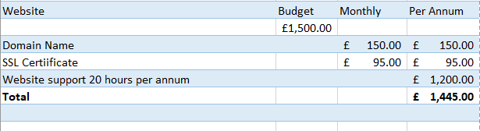
Recommendation
That the Resources Committee authorises 2- 3 hours a month website support from Herringbone for the first 6 months of the year dropping down to 1 hour a month after. (20 hours at £60 an hour at a total cost of £1200 per Annum)

- IT Support & Software
The Town Council’s Software and It costs have significantly increased over the last year due to Covid-19 and improvements to financial management. Some items could be coded to communication and subscriptions. The Clerk is asking Council to note the increased costs and be aware of a potential overspend.

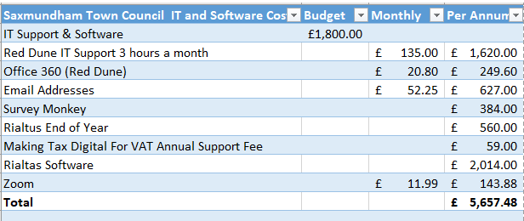

Item no: | 9
Report dated: | Wednesday, 14 April 2021
To the: | Resources Committee
Meeting on: | 26 of April 2021
Subject: | Assistant Clerk Hours
Contact/author: | Roz Barnett – Town Clerk

- Summary.
1.1 The Assistant Town Clerk’s (ATC) working week was reduced from four days to three days from 1st April 2021.

1.2 The Assistant Clerk’s workload will include, clerking the Planning Committee, Neighbourhood Plan Steering Group, Health and Safety checks for premises, and practical matters related to the Market Hall.

1.3. After looking at the detail of this workload with the Assistant Clerk it is proposed that her hours are increased to 22.5 hours per week.
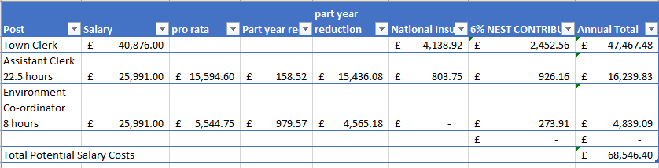

NB The Government have announced a public sector pay freeze for 2021/2022 although for those individuals earning over £24,000.

- Legal power to make the decision
2.1 Power to appoint staff, Local government Act 1972, s.112.

2.2 Ancillary power to do anything that will facilitate, be conducive to or incidental to the discharge of its powers and functions, Local Government Act 1972, s.111.

- Options
3.1 Leave the ATC’s hours at 21 hours a week.

3.2 Increase the ATC’s hours to 22.5 hours per week.

3.0 Recommendation.
3.1 That the Resources Committee recommend an increase in the ATC’s hours to 22.5.

SAXMUNDHAM APPRAISAL SCHEME
INTRODUCTION
The appraisal scheme provides the Council with a framework to regularly review an employee’s performance, and the employees with an opportunity to give feedback to their employer.
The Resources Committee have the oversight of the Appraisal Scheme process and ensuring that it is completed.

WHO UNDERTAKE APPRAISALS?
The Town Clerk is responsible for the staff performance management meetings and appraisals of all staff.
The Staffing Committee are responsible for the performance management and appraising the Town Clerk.
The Chair of the Staffing Committee and the Chair of the Council are responsible for setting the Objectives for the Town Clerk at the beginning of each financial year.
Summary reports from all appraisals will be shared with the Resources Committee.

CORE ASPECTS OF THE PERFORMANCE MANAGEMENT PROCESS
The Council’s Annual Plan
The Council’s Annual Plan should set out the Council’s objectives and key areas of work for completion. The plan objectives should be reflected in the performance management target for staff.

The Role of the Staffing Committee (See also Staffing Committee Terms of Reference)
The Staffing Committee will:
· ensure that annual appraisals are being conducted for all staff;
· organise the process for the Town Clerk’s appraisal;
· be responsible for reviewing the performance management process to ensure it continues to meet the Council’s needs;
· will countersign the appraisals for all staff; and
· will hear any grievances raised by staff in relation to their appraisal. (subject to compliance with the ACAS Code of Practice on the conduct of grievance procedures).

The Annual Appraisal and Mid-Year Review
The annual appraisal and mid-year reviews and catch-up meetings will follow the format set out in this document with supporting forms for the annual and mid-year reviews.

The Role of Regular Catch-Ups
Catch-ups should be conducted every six weeks or so. Meetings may be more frequent where staff are new to their post, the employee requires more regular support or the manager is concerned that the employee needs particular attention. Equally catch-ups can take place less frequently where appropriate. However, they should always take place at least every 8 weeks/2 months. Catch-ups provide the opportunity for regular discussions on progress against objectives highlighting where additional support may be needed or, in exceptional situations, where objectives should be amended. They also provide an opportunity to discuss a range of other day to day matters such as annual leave or TOIL arrangements; recent or planned absence; workload pressures; progress with learning and development plans etc.

STRUCTURE OF THE APPRAISAL MEETING AND MID-YEAR REVIEW
The appraisal meeting and mid-year reviews are in two parts. The first part looks back over the appraisal period. It looks at:
· the extent to which the objectives have been met;
· noting any achievements
· whether the job description has changed;
· whether the learning and development objectives have been achieved; as well as
· noting any other general comments.

The second part looks forward to the next appraisal period. It provides an opportunity to:
· discuss the objectives to be set;
· identify the learning and development needs.

USING THE RECORD OF APPRAISAL FORM
The form is produced as a Word document to allow flexibility. The form is not intended to restrict the amount which can be written or the number of objectives which can be set (The form Is an ACAS template).

SETTING OBJECTIVES
All team and individual objectives should be written as SMART objectives. The number of objectives set will depend on the ‘size’ of each objective and the other work which a member if staff is tasked with. If appropriate objectives should have supporting information such as ‘milestones’ to be achieved or additional information to clarify how the objective should be met or what support might be available.

RECORD KEEPING
A written record of the appraisal, mid-year review and catch-up meetings will be given to the employee for their own records and copies will be kept in the employee’s personnel file. The written record of appraisal, mid-year review and, catch-up meetings for the Town Clerk will be held by the Chairman of the Staffing Sub-Committee on behalf of the Committee, as well as in the Town Clerk’s own personnel file and a copy given to him/her. Should the Chairman of Staffing Committee change then these records will be made available to them and any other member of the Staffing Committee appointed to conduct an appraisal meeting (either full or mid-year)
SEEKING AGREEMENT
Wherever possible agreement should be sought for the objectives set. It is important for the appraiser to listen carefully to any concerns raised by the ‘appraisee.’ However, if agreement cannot be reached then the disputed objectives can be referred to the Staffing Committee who will consider whether to amend, withdraw, or retain them after having considered the matter. Wherever possible, agreement should be sought for the other aspects of the appraisal (i.e. looking back at past achievements, training required, etc.). However, where agreement cannot be reached a note of the employee’s comments/objections will be kept together with the appraisal report.
THE RELATIONSHIP BETWEEN THE TOWN CLERK’S APPRAISAL AND OTHER STAFF
For clarity, the Town Clerk appraisal process is entirely independent from that of other members of staff. In other words, if for any reason any stage of the Town Clerk’s appraisal is delayed in full or in part - then this should not delay any element of the (including objective setting) appraisal process progressing.

Staffing Sub- Committee (Previously Agreed)

Prime Objectives
To consider grievance or disciplinary matters (not including any appeal therefrom) referred and to manage the Clerk.

Membership and Frequency of Meetings
The Sub-Committee comprises 4 voting members of the Town Council.
The Sub-Committee reports to the Resource Committee.
The Quorum for this Committee shall be 3 members.
The Staffing Sub-committee will meet as required based on the business to discuss.

Delegated Business
The Sub-Committee has delegated authority and responsibility to deal with the following matters to conclusion:
- To consider grievance or disciplinary matters for all staff in accordance with the council’s grievance and disciplinary policies.
- To manage, supervise and appraise the Clerk, administer leave requests, record and monitor absence from work.
- To recommend to the Resource committee any actions regarding the Clerk’s performance and to recommend salary and benefit levels for the Clerk.
- To consider any other item that Resource Committee or Full Council deem appropriate.

Adopted: ______________________

Item 11
To the councillors of Saxmundham
Re: Grant for a community film event for Saxmundham
Run by St John’s church Grant applied for £500
A contribution is sought by St John’s church to provide a community event for the people of Saxmundham. It is hoped that by investing in our community we will strengthen its identity. We are a not for profit group and any profits made will be ploughed back into the community.
St John’s is involved within the town in many ways, it has established a strong link with IP17 and many of the church members offer practical support, from helping with the covid rollout, setting up a community fridge and hosting the community Carol Service. The church seeks to serve the people of Saxmundham by providing a community event.
We are planning to have an outside Big Screen film event on 28th August a deposit has been paid and the school has been booked. On the Sunday 29th August there will be a community picnic. On the Sunday morning the church is planning an outside community service at the school.
The Film will be on a screen which is 6 metres by 3.5 metres.We will be showing two films, and adult film and a children’s film. The screen has been booked with Southern Screen Hire and a deposit paid.
The total cost of the event is £2110 ( or £2610 if we need to provide outside toilets) The Saturday Big Screen event will start at 3.00pm for children and at 7pm for adults and over by 9pm. Each screening can accommodate up to 500 ( restriction on numbers because of licence) and it will be a ticketed event.
Both events will follow guidelines set by government and adhere to covid rules, and a full risk assessment will be carried out by an experienced health and safety volunteer who has given their time free.
local volunteers will be used and where possible local companies for work involved.
Breakdown of costs:
Screen Hire £1800
Rent for school £110
Film Licence £100
Printing £200
Toilets if needed 400
Total: £2610
Community Picnic
1.00-3.00pm
No anticipated cost, toilets.
This will be not be a ticketed event and numbers not restricted, there will be music and games for the children.
We hope these events are successful that it could be an annual event for the people of Saxmundham.
Money raised so far
Waitrose £333
Profit from Wreath kits sold at Christmas £100
St John’s
Grants applied for Tesco community fund and Saxmundham Rotary
Insurance St John’s church

I hope these notes have been useful in explaining why I am asking for support for the project, I am committed to the community of Saxmundham, I have only lived here for five years but want to support events and to bring the community together with events. I have had experience of running events in my previous town in Cheshire and would love to use my skills for Saxmundham .

